**REACT LEARNING – 15 hr Course Work**

**Project 1:  
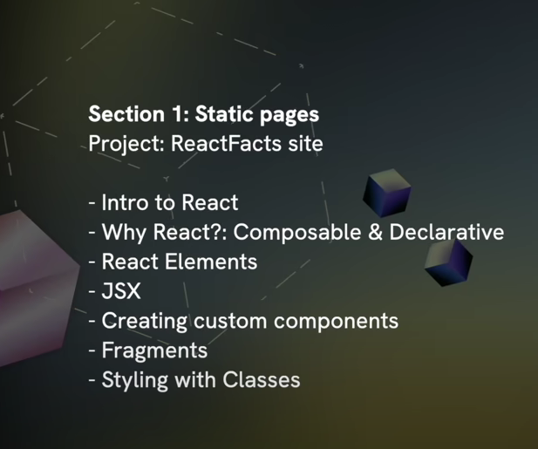**

**Fragments** are important in React because they allow you to render multiple lines of JSX (React Elements) without getting any errors

Eg.   
<>  
{Stuff}  
<div></div>  
</>

**Project 2:  
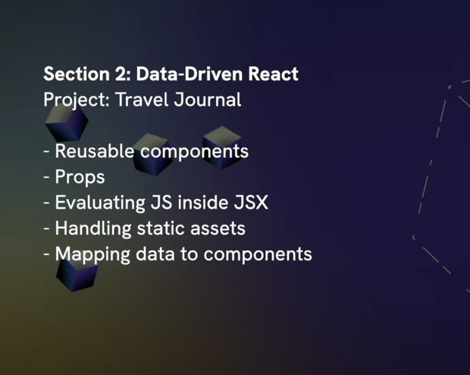**

**Project 3:  
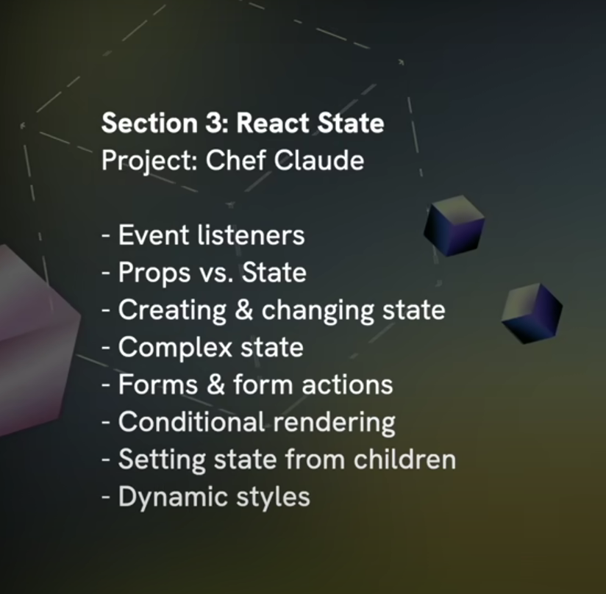**

**Project 4:  
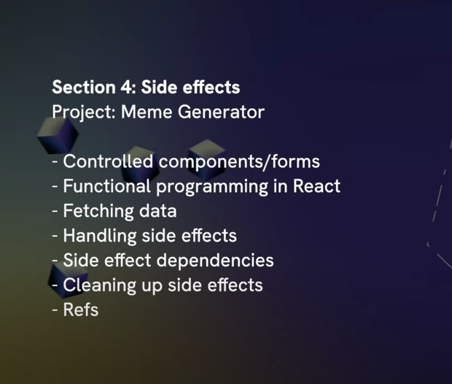**

**Project 5: Applying Everything  
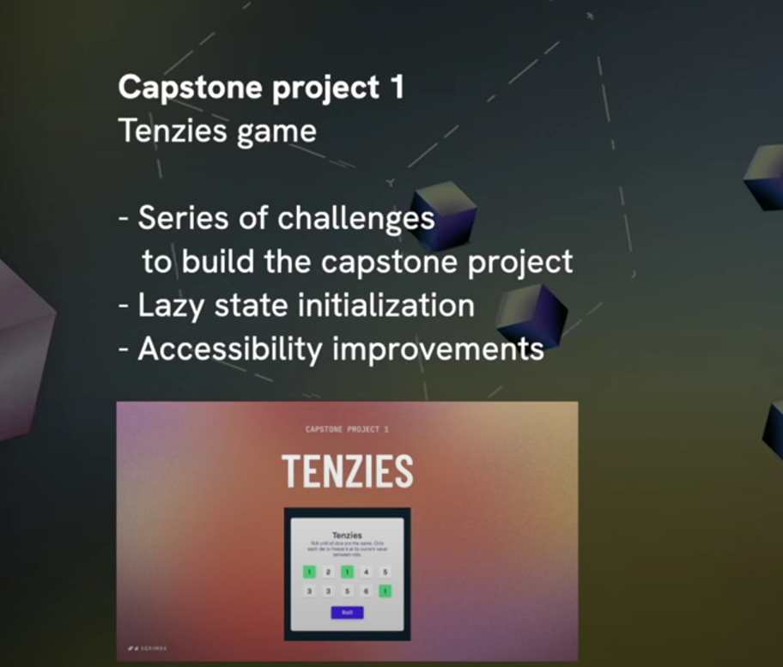**

**Project 6: Applying Everything**

